



PROJECT REPORT
React JS
Connectify – Professional Networking Platform

Page left blank intentionally

INDEX
1 PROJECT DETAILS 2
2 SUMMARY 2
3 INTRODUCTION 2
3.1 Background 2
3.2 Stakeholders 2
3.3 Objectives 2
4 METHODOLOGY 2
4.1 Considerations & Assumption 3
4.2 Approach 3
4.3 Activities 3
5 TARGETTED V/S ACHIEVED OUTPUT 3
6 CONCLUSION 3
7 APPENDICES 4
7.1 Appendix A – Title 4

General Instructions for using the Live Project Report Template
- This template and the subsequent document created using this template is a confidential document and is the intellectual property of Cloud Counselage Pvt. Ltd. Circulating it outside of the organisation without the consent of Cloud Counselage Pvt. Ltd. is the breach of company policies and will lead to legal actions
- This template is a guideline document to communicate the implementation of design ideas and the results of the work to the stakeholders.
- The text between inequality (< >) is to be replaced by relevant text
- Please remove the yellow highlight on the Text between the inequality (< >). This is done to help you notice the text to be changed/replaced
- The text in italics highlighted in grey is just for reference and should be removed after adding the relevant text

PROJECT DETAILS

Project Name | Connectify – Professional Networking Platform
Project Sponsor | Cloud Counselage Pvt. Ltd.
Project Manager | ADIB AFSAR
Start Date | 28-Jul-2024 | Completion Date | 28-Oct-2024

SUMMARY
Connectify is a LinkedIn-inspired professional networking platform developed using React.js and Firebase. The application enables students and professionals to create detailed profiles, build meaningful connections, discover job opportunities, share content, and communicate through real-time messaging.
The project was initiated to solve the problem of fragmented professional networking experiences by providing an integrated platform for career growth and engagement.
The long-term benefits of the project include improved networking opportunities, enhanced visibility of professional skills, streamlined job discovery, and increased user engagement through notifications and social interactions.

INTRODUCTION

Background

Modern professionals and students often struggle to build meaningful connections and discover relevant career opportunities on a single platform.
Connectify addresses this challenge by providing a centralized networking ecosystem where users can create professional profiles, showcase their skills and experience, share updates, search for jobs, and interact with other users through messaging and notifications.

Stakeholders

The primary stakeholders of the project are:
- Students seeking internships and career opportunities
- Working professionals seeking networking opportunities
- Recruiters and job providers
- Cloud Counselage Pvt. Ltd.
- The project developer
- Future employers evaluating the platform

Objectives

The objective of Connectify is to develop a professional networking platform using React.js and Firebase that enables users to:
- Create and manage professional profiles
- Connect with other users
- Share posts and updates
- Search and publish job opportunities
- Exchange messages in real time
- Receive notifications for user engagement
- Upload and manage media files

METHODOLOGY
These conventions are all about the positions of line breaks, how many characters should go on a line, and everything in between.

Considerations & Assumption

The project was developed using personal Firebase services, including Firebase Authentication, Cloud Firestore, and Firebase Storage.
Key considerations included optimizing React component rendering, managing real-time data synchronization, and ensuring a responsive user interface.
It was assumed that users would have internet access and Google accounts for authentication.

Approach
The project followed an iterative development approach.
Requirements were analyzed based on the problem statement and transformed into modular React components.
Redux was used for state management, while Firebase services handled authentication, data storage, and media uploads.
The application was deployed on Vercel for public accessibility.

Activities

Requirement gathering and analysis
UI design and component planning
Firebase project setup
Google authentication integration
Firestore database design
Profile module development
Post creation and engagement features
Job posting and search implementation
Messaging and notification development
Testing and debugging
Deployment on Vercel
Documentation preparation

TARGETTED V/S ACHIEVED OUTPUT

Targeted Output | Achieved Output
Google Authentication | Implemented
User Profiles | Implemented
Post Creation | Implemented
Likes and Comments | Implemented
Job Posting | Implemented
Messaging | Implemented
Notifications | Implemented
Media Uploads | Implemented
Deployment | Implemented on Vercel

Minor deviations were observed in advanced features such as push notifications and recommendation systems due to time constraints. These features have been identified as future enhancements.

CONCLUSION
Connectify successfully delivers a modern professional networking experience by integrating profile management, social engagement, job discovery, and real-time communication.
The platform demonstrates the effective use of React.js, Redux, Firebase Authentication, Cloud Firestore, and Firebase Storage in building scalable web applications.
Future enhancements include push notifications, AI-powered recommendations, advanced search filters, and mobile application support.

APPENDICES

Appendix A – Technology Stack

Category | Technology
Frontend | React 18.3.1
State Management | Redux 5.0.1
Authentication | Firebase Authentication
Database | Cloud Firestore
Storage | Firebase Storage
UI Library | React Bootstrap
Styling | CSS, Styled Components
Routing | React Router DOM 6.26.2
Deployment | Vercel

Deployment URL: https://connectify-prod.vercel.app/

Application Screen shots -

Login page
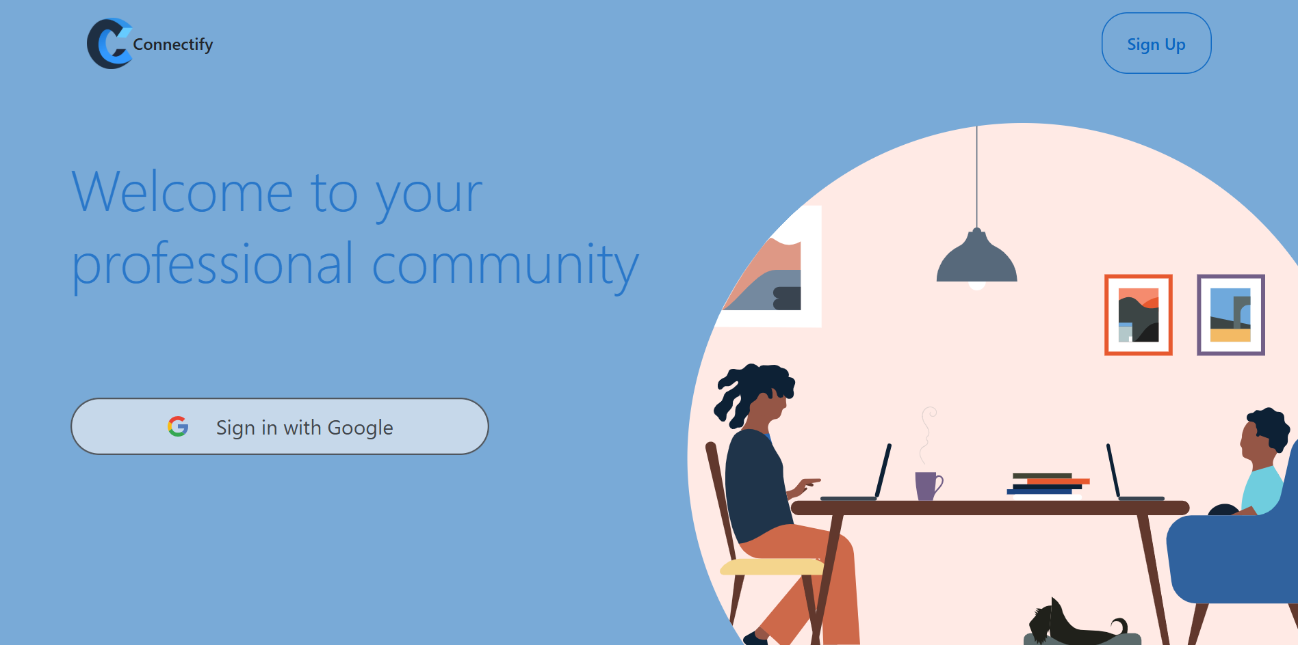

Home feed
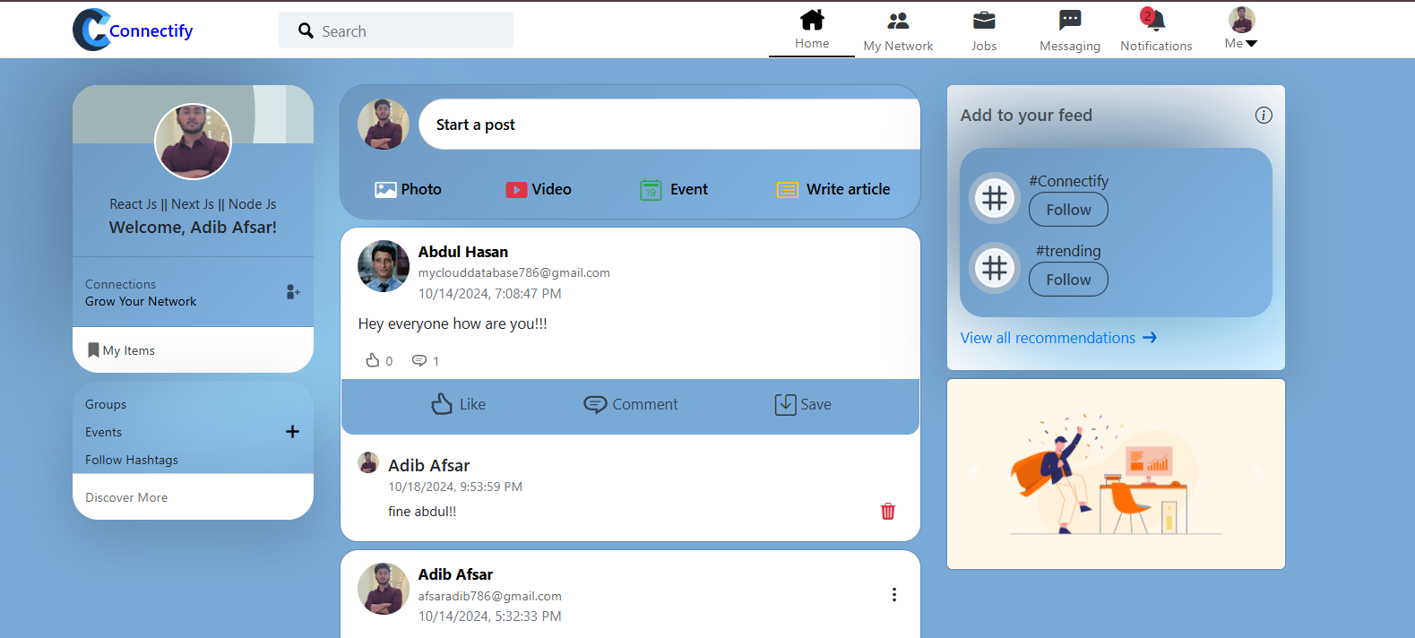

Profile page
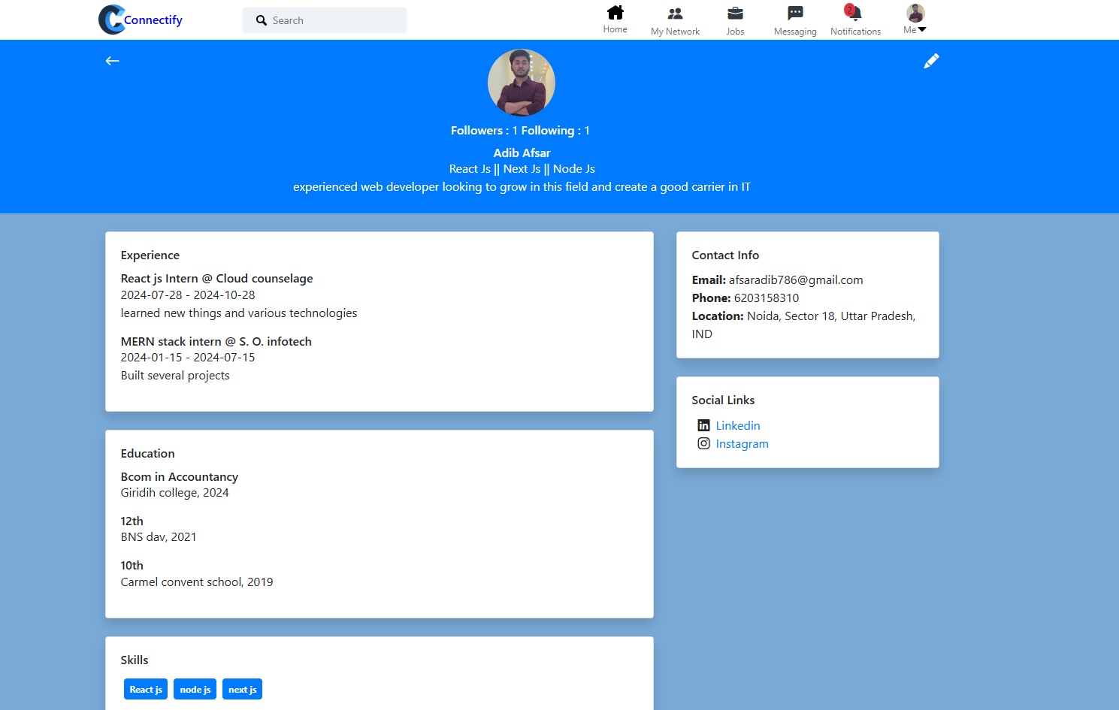

Messaging page
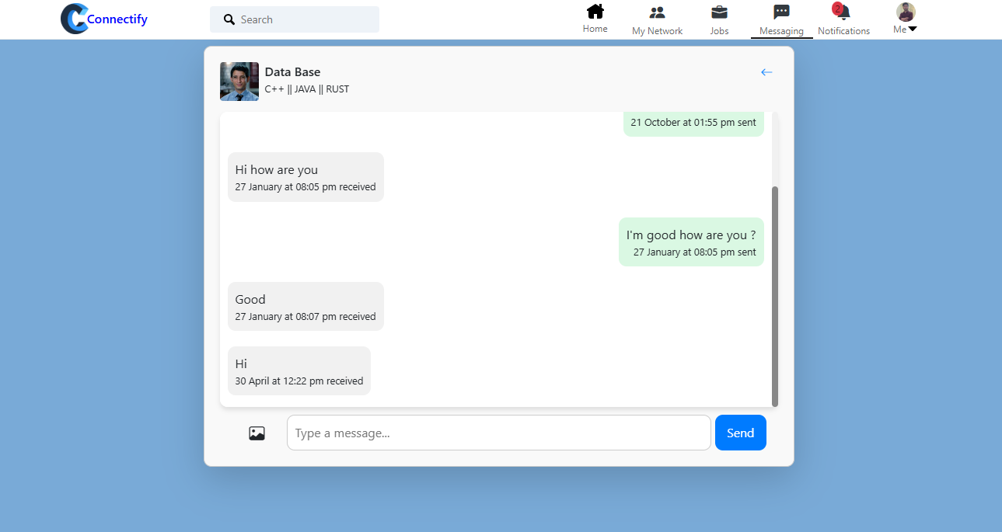

Notifications page
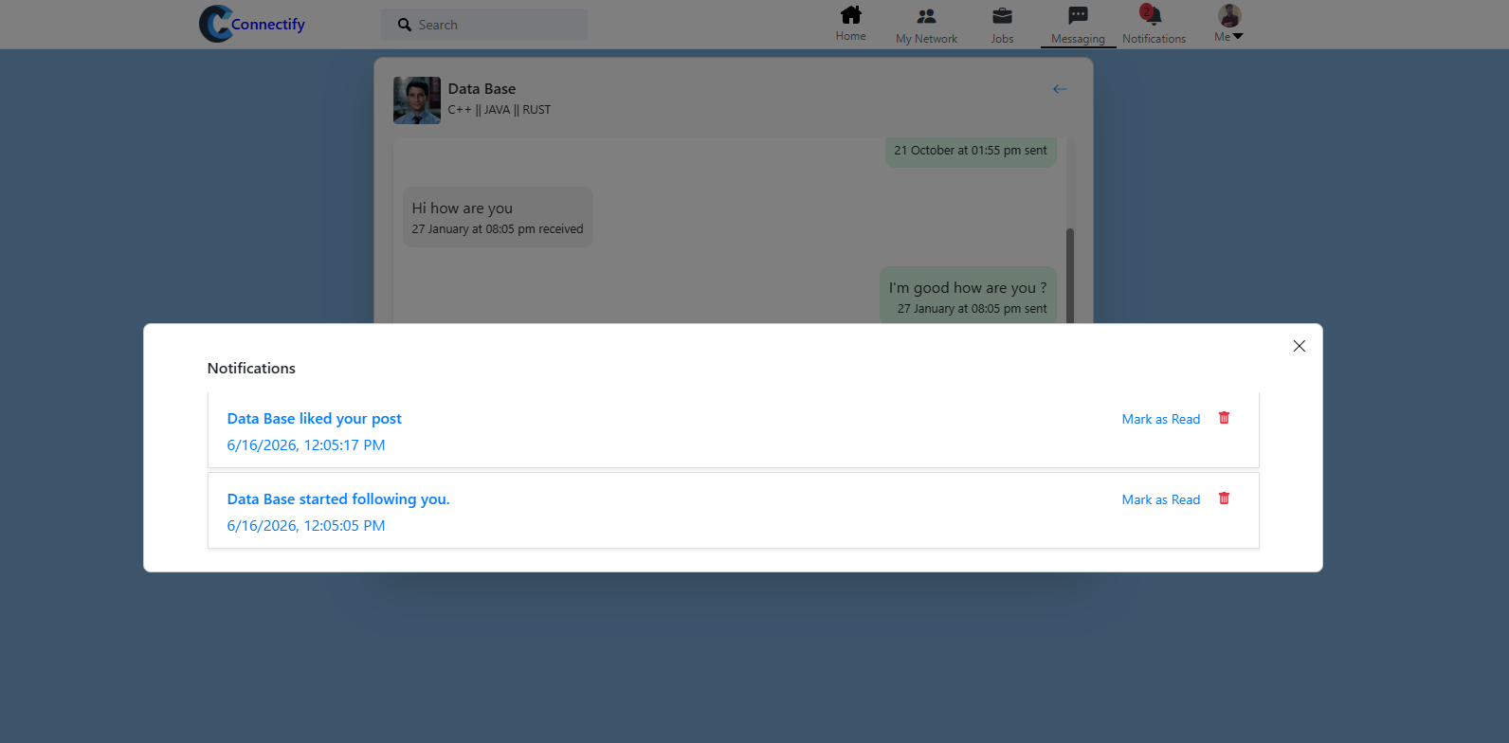

Job search page
